Chapter: Understanding Kubernetes Services and Their Practical Implementation

Introduction: The Significance of Services in Kubernetes
- [00:00 → 01:05]
In the Kubernetes ecosystem, services play a crucial role in making applications accessible and enabling communication between various components within a cluster. This chapter explores the fundamental concept of Kubernetes services, which act as an abstraction layer that exposes pods (the smallest deployable units) to internal or external consumers. Key vocabulary includes NodePort, ClusterIP, LoadBalancer, and ExternalName, which represent different service types used to expose applications in varied contexts.
- Services ensure loose coupling by abstracting pod IPs, exposing pods on specified ports, and enabling communication across different layers such as front-end, back-end, and databases.
- The ability to expose applications externally or internally is essential for real-world Kubernetes deployments, especially for front-end applications accessible to users.

Section 1: The Role and Types of Kubernetes Services
- [01:36 → 03:26]
Kubernetes services enable communication between pods and outside users. For example, a front-end pod communicates with back-end pods, which in turn access external data sources. Services provide a stable network interface despite dynamic pod IPs, ensuring seamless connectivity.
- The main service types discussed are:
  - NodePort: Exposes the service on a static port on each node’s IP.
  - ClusterIP: Exposes the service on a cluster-internal IP. This is the default service type.
  - LoadBalancer: Creates an external load balancer (usually cloud-provided) to distribute traffic.
  - ExternalName: Maps a service to a DNS name external to the cluster.

Section 2: Deep Dive into NodePort Service
- [03:26 → 08:27]
The NodePort service exposes an application on a static port between 30000 and 32767 across all nodes. Traffic arriving at this port is forwarded to the pod’s internal TargetPort. Three key ports are involved:
  - NodePort: static port (30000–32767) externally accessible on every node’s IP for external traffic
  - Port: The port exposed by the Service object inside the cluster (ClusterIP). It is used by other pods/services in the cluster.
  - TargetPort: The port inside the Pod container (e.g., Nginx listens on 8080).
- Example setup: NodePort 30001 maps to Port 80 (service port) and TargetPort 80 (pod port).
- NodePort service load balances across multiple pods behind the service using a round-robin mechanism.
- This service type is typically used when exposing an application externally without an external load balancer.

Section 3: Implementing NodePort Service in Practice
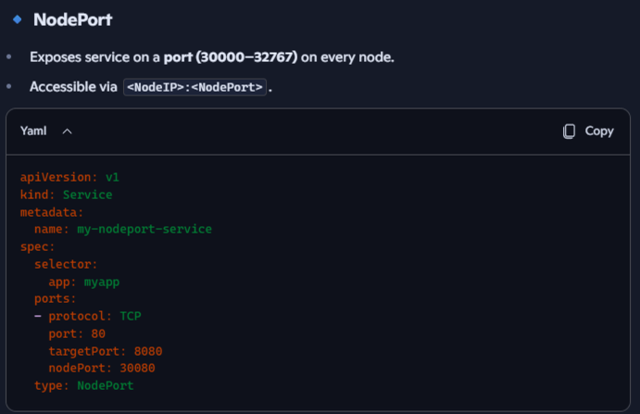
- [08:27 → 16:12]
The speaker walks through creating a NodePort service YAML file, specifying fields such as apiVersion, kind: Service, metadata, spec.type: NodePort, and ports configuration.
- The selector field matches the service to pods by labels (e.g., env: demo), enabling the service to route traffic correctly. kube-proxy load-balances traffic across all Pods that match the Service selector.
- Important lessons include:
  - Kubernetes is case-sensitive, e.g., NodePort must be capitalized correctly.
  - NodePort must be within the valid range (30000–32767).
- Upon creating the service, kubectl get svc confirms the service IP and exposed ports.
- The Service opens the same port (e.g., 30080) on every node in the cluster. External clients can connect to <any-node-IP>:<nodePort>. Port is opened on all nodes as kube-proxy ensures that traffic hitting any node’s NodePort is forwarded to the Service, even if that node doesn’t run the Pod.
- NodePort = ClusterIP + external port on every node. It’s a way to expose services without a cloud load balancer.
- The actual external accessibility depends on the cluster environment; for example, kind clusters require additional port mapping configuration to expose NodePorts externally.

Section 4: Special Considerations for Kind Cluster and Port Mapping
- [16:12 → 26:58]
Kind (Kubernetes in Docker) clusters do not expose NodePort services externally by default. To make services accessible on the host machine, port mappings must be added to the kind cluster configuration YAML.
- This involves adding a port mapping rule under the control-plane role in the kind cluster spec, mapping container ports (e.g., 30001) to host machine ports.
- The cluster must be recreated after this change for it to take effect.
- This extra step is specific to kind clusters and not required in standard on-premises or cloud Kubernetes environments.
- After applying this fix, the application becomes accessible via localhost:30001.

Section 5: ClusterIP – Internal Communication Between Pods
- [30:11 → 37:43]
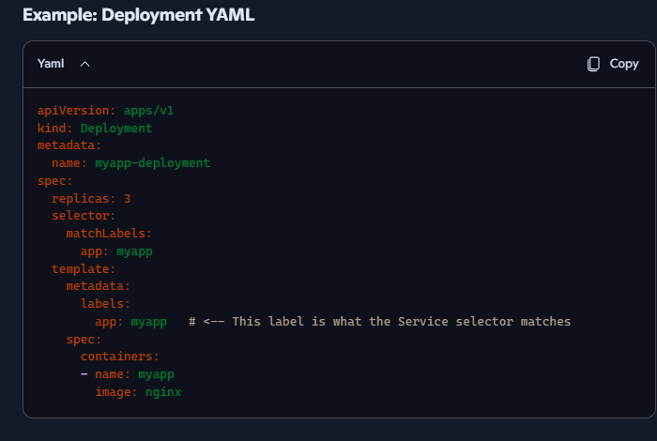
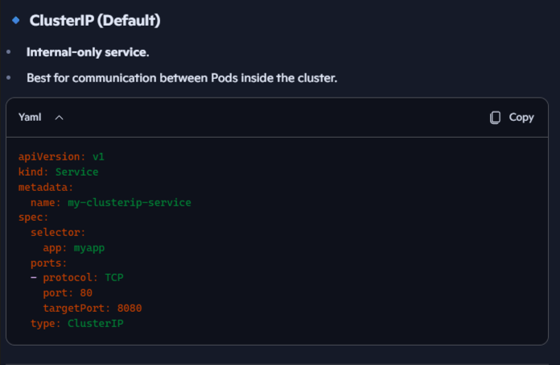
Pods have dynamic IPs that change on restart, making direct IP-based communication unreliable. The ClusterIP service provides a single stable internal virtual IP address to enable pods to communicate within the cluster. That IP maps to all Pods matching the Service’s selector (e.g., all Pods in a Deployment with app=myapp)
- ClusterIP is the default service type and is used to facilitate backend communication, such as front-end pods talking to backend services or databases.
- The service maintains an endpoint list that tracks the current pod IPs behind the service.
- Kubernetes uses kube-proxy to maintain iptables/IPVS rules. Incoming traffic to the Service IP is load-balanced across the matching Pods (round-robin by default). If a Pod dies, kube-proxy updates the rules automatically.
- Creating a ClusterIP service requires specifying the type as ClusterIP (or omitting the type since it’s default), along with ports and selectors.
- This internal IP is not accessible externally and is intended for intra-cluster communication.

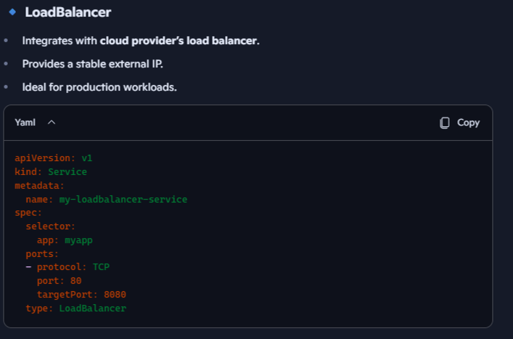
Section 6: LoadBalancer Service – Simplifying External Access
- [37:43 → 43:26]
For applications spanning multiple nodes and pods, exposing each pod IP externally is impractical. The LoadBalancer service type addresses this by providing a single external IP or DNS that users can access.
- LoadBalancer services rely on cloud provider integration (e.g., AWS, Azure, GCP) to provision external load balancers automatically.
- LoadBalancer builds on NodePort. In cloud environments (AWS, GCP, Azure), Kubernetes asks the cloud provider to provision a real external load balancer. That LB forwards traffic to the NodePort(s), which then reach the Pods. LoadBalancer = NodePort + cloud provider integration.
- The load balancer distributes incoming traffic across pods behind the service based on load balancing algorithms.
- In local or kind clusters, an actual external load balancer is not provisioned by default. The service behaves like a NodePort service until a load balancer is provisioned.
- Kubernetes documentation provides tools for simulating load balancers in kind clusters, but this goes beyond the scope of the basic Kubernetes concepts.

Section 7: ExternalName Service – Mapping to External DNS
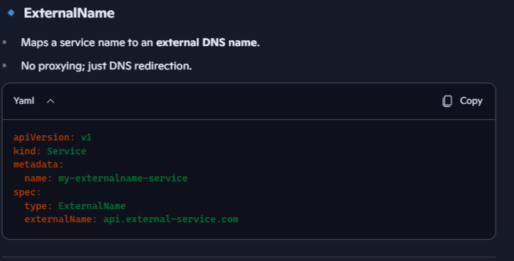
- [43:26 → 44:40]
A Service that doesn’t point to Pods at all. Instead, it is just dns aliasing that maps to an external DNS name.
- The ExternalName service type allows internal services to reference external DNS entries, such as databases, APIs, or third-party services outside the cluster. When a Pod inside the cluster does nslookup my-external-service, it gets database.example.com. No kube-proxy rules, no Pods involved.
- It is used to give internal clients a consistent Kubernetes Service name while actually pointing to something outside the cluster (like a managed DB, SaaS API, or legacy system). it must be resolvable by the cluster’s DNS (usually CoreDNS).
- It is useful for integrating external systems into internal cluster workflows.
- ExternalName = DNS alias inside Kubernetes → points to an external service. No Pods, no load balancing.

Section 8: Alternative Ways to Create Services and Practical Tips
- [44:40 → 46:24]
Kubernetes services can be created declaratively (via YAML files) or imperatively using command-line commands such as kubectl expose deployment.
- This command simplifies service creation by exposing a deployment with specified ports and service types.
- The speaker also mentions best practices for improving productivity, such as setting shell aliases (alias k=kubectl) and enabling bash completion to streamline Kubernetes command usage.

kubectl expose deployment myapp-deployment --name=myapp-clusterip --port=80 --target-port=8080 –type=ClusterIP
kubectl expose deployment myapp-deployment --name=myapp-nodeport --port=80 --target-port=8080 --type=NodePort –node-port=30080
kubectl expose deployment myapp-deployment --name=myapp-loadbalancer --port=80 --target-port=8080 –type=LoadBalancer
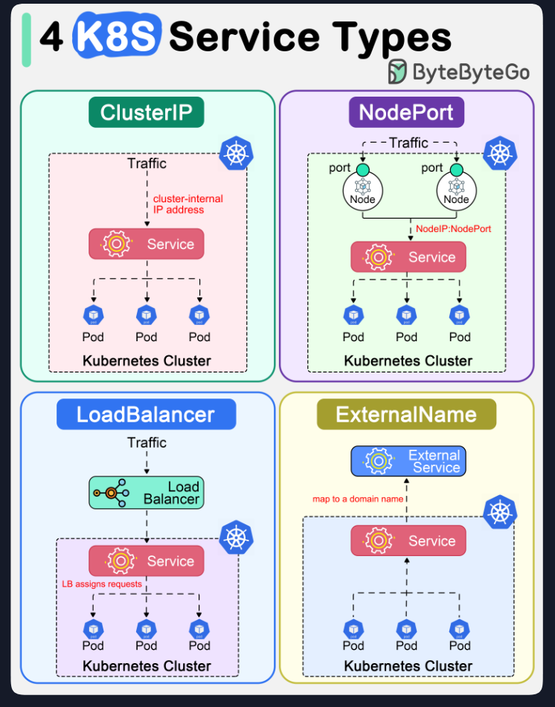
kubectl create service externalname my-external --external-name=db.company.com

